Mini Activity 5: Write a program that asks the user for two numbers and adds them

Test Date | What you expect to happen | What happened | Screenshot | How you fixed it | What type of error did you have? Compile, run time or logic?
9/11/2025 | Two numbers to be added together. | I put in 5 and 6. Got back 56 | 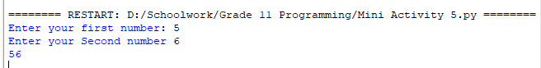 | Made the input convert to an integer. | Wrong code.

